IMPORTANT STEPS IN THE DEVELOPMENT OF CIVILISATIONS

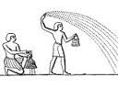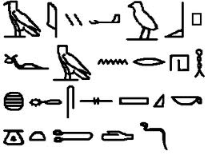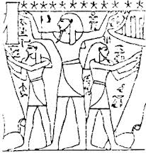

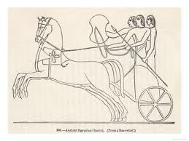

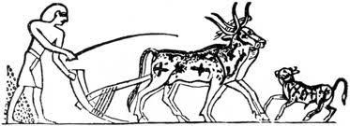
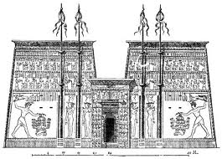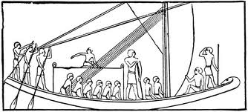

IMPORTANT STEPS IN THE DEVELOPMENT OF CIVILISATIONS
The taming of animals meant a constant source of meat and labour.
The planting of crops meant that man had a dependable and constant source of food
The development of government brought law and order to the community.
The use of metals enabled man to develop new tools and weapons.
The building of the first settlements.
The discovery of writing meant that man could record his ideas for others to use.
The development of religion inspired man to build great temples and to create works of art.
The important discovery of the wheel changed man’s method of transportation.
Trade greatly improved the life style of the people and encouraged exploration and contact with other civilisations.

